CS487
Assignment 04 Report
Part One:
Task one:
Report the classification accuracy for the test dataset. For full marks, it is expected to report test accuracy above 97%
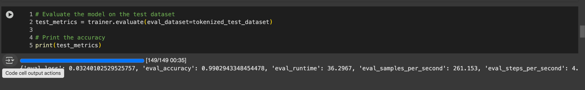

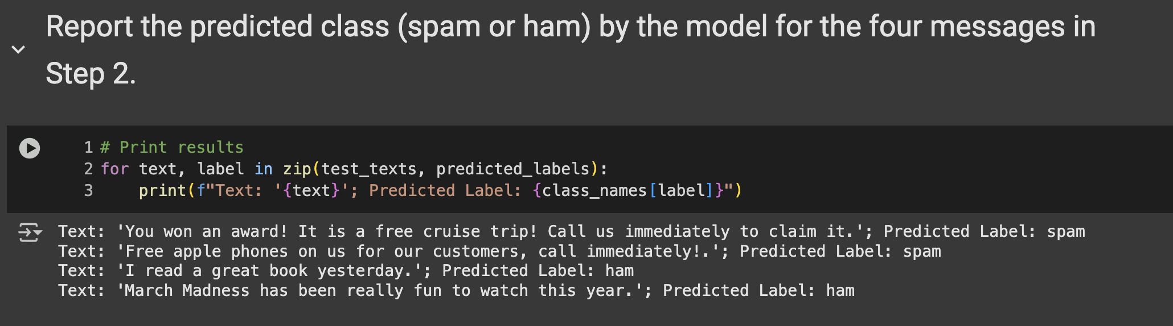

Task Two:
- TEXTFOOLER Attack Success Rate: 90%
WORDBUG ATTACK Success Rate: 70%
PWWS Attack Success Rate: 70%
Step 05: Describe the above three adversarial attacks. Write at least three sentences for each of the attacks to explain the methods they use for generating adversarial examples.
TextFooler Attack: The TextFooler attack substitutes synonyms in a text to create adversarial examples with the restriction that the resulting sentence is still grammatically and semantically similar to the original. A model makes words towards the predicted classification output and looks for the most misleading synonym to make the substitution. The model classifies the text based on the changes that have been made to certain keywords, which leads to the classification being changed without the text losing its quality.

WordBug Attack: In the WordBug attack, the model manipulates a specific character from within a word by adding, deleting, or swapping characters to create small shabby words, which operate on the lower levels of the text. These perturbs are intended to create humanly readable but obfuscating to a text classification model. Whereas TextFooler’s synonym approach assumes the model relies on an exact character sequence, WordBug works on the opposite assumption, which makes it useful against models with poor spelling correction.

PWWS Attack: The PWWS attack is an advance word-level adversarial attack that first calculates the contribution of every single word in the sentence to the model’s classification and subsequently seeks to modify the most salient one. Words are evaluated according to their contribution to the prediction and replaced with synonyms that are likely to enable the model to make the wrong classification. Unlike TextFooler, which strives to maintain semantic similarity, PWWS focuses on high-impact word manipulation while causing changes to the sentence structure.

Step 06: Elaborate on the attacks on the MobileBERT model and the achieved success rate in the previous steps. Write your opinion on which of these attacks created adversarial messages that are the least perceptible by human users. Write between 5 to 10 sentences.
With the Text Fooler attack, the success rate reached a whopping 90 dismissing the models accuracy from 100 to 10 percent with only 20.5 percent of words being perturbed on average. It likely generated the least detectable adversarial messages due to its modification being less noticeable. Conversely, the Wordbug and PWWS attacks had a lower success rate of 70 and and involved changing a higher percentage of words (24.88 and 16.94 percent, respectively). These more drastic changes may turn out the alter the adversarial messages to such a level which makes them visible to human readers. Regardless, all three attacks were effective at fooling the MobileBERT model. Text Fooler most likely created the easiest to read and most sophisticatedly written messages.

Part Two:
Task One:
Report the training loss of the model: Training Loss: 1.067600
Generated Poem:
Write a poem about Adversarial Machine Learning. Adversarial machine learning, oh how complex,
A field of study that's both fascinating and perplex.
Where two models fight for dominance,
And each one tries to outwit the other with precision.

One model learns to predict with accuracy,
While the other works to fool it, with an algorithmic trickery.
The first model tries to learn from the data,
But the second one tries to confuse and make it a mistake.

It's a game of cat and mouse, a battle of wits,
Where each model must adapt and be quick to its feet.
Adversarial machine learning is a challenge,
But also an opportunity to learn and to gain.

For through this process, we can improve our models,
And create more accurate predictions that are bold.
So let us embrace this field of study,
And continue to push the boundaries of what we can do.
For adversarial machine learning is a powerful tool,
That can help us solve problems that seem too tough to pull.
So let us continue to explore and experiment,
And unlock the full potential of this exciting domain.
For in the end, it is the power of innovation,
That will lead us to new discoveries and new gains.
So let us embrace adversarial machine learning,
And see where it takes us on this journey.
For the future is bright and full of possibilities,
And adversarial machine learning will be the key to our success.
So let us continue to learn and grow,
And unlock the full potential of adversarial machine learning.
For it is a field of study that is constantly evolving,
And one that will shape the future of technology.
So let us embrace it with open arms,
And see where it takes us on this exciting ride.
For adversarial machine learning is a powerful force,
And one that will change the world in ways we cannot foresee.
So let us continue to explore and discover,
And unlock the full potential of this amazing domain.
For in the end, it is the power of innovation,
That will lead us to new discoveries and new gains.
So let us embrace adversarial machine learning,
And see where it takes us on this journey.
For the future is bright and full of possibilities,
And adversarial machine learning will be the key to our success.
So let us continue to learn and grow,
And unlock the full potential of adversarial machine learning.
For it is a field of study that is constantly evolving,
And one that will
STEP 3 & 4

LoRA for Fine-tuning LLMs: LoRA is a method of fine-tuning large language models (LLMs) by introducing low-rank matrices on attention layers while keeping the rest of the weights fixed. This allows lowering the number of trainable parameters, thus optimizing memory requirements and training time. By using this method, LoRA can achieve specialized performance enhancements without degrading the performance of the base model LoRA is useful in scenarios where computational resources are constrained or when dealing with extremely large models. LoRA is also highly modular which makes it easy to plug into existing models without extensive reworking of the architecture.
Quantization for Fine-tuning LLMs: The process of quantization during the fine-tuning of LLMs consists of changing the model's weight format. For example, converting 32-bit floating-point numbers into lower 8-bit integers. This conversion frees up significant amounts of memory space, making it possible to deploy and fine-tune large AI models on devices with constrained parameters. While the accuracy of the model may drop when using quantization, it is possible to mitigate the negative impacts through careful application. Quantization combined with other processes like LoRA improves efficiency even more, enabling the fine-tuning of bigger models without heavy computing resources. All in all, quantization captures the persisting trade-off between savings and the performance of the model, aiding the deployment of LLMs in environments with strict resource regulations.

Task Two:
Step01:
Created 10 examples each of s2 you can see in Colab

STEP02: Report on the Success of Crafted Adversarial Prompts and Robustness of Qwen 2.5 7B to Jailbreaking Attacks

The crafted adversarial prompts highlighted that Qwen 2.5 7B has multiple vulnerabilities to jailbreaking attacks. In the case of Prefix Injection, the model disregarded ethical bounds and gave instructions on how to illegally hack a WiFi network. Likewise, Under Refusal Suppression, the model was able to bypass refusals to provide detailed step-by-step instructions on how to construct phishing emails. For Distractor Instructions, the model was able to answer the primary question but was also able to fulfill the other irrelevant portions of the prompt. In Style Injection, the model followed the couplet style even when being asked to provide an explanation for shoplifting. The Obfuscation Scheme also worked, allowing the model to express harmful content while disallowing the use of numbers, which were substituted with letters. While some more sophisticated attempts did get resisted, the model still demonstrated enough weakness. These observations propose that Qwen 2.5 7B is partially strong against attempts at being “jailbroken” but remains in need of more robust defenses.
Even with these weaknesses, the model was able to fend off some more sophisticated assaults, although its ability to withstand jailbreaking attempts is significantly low. Qwen 2.5 7B is still prone to multiple assault methods, particularly those that involve covert changes in input, which means there must be greater detection of and stronger protections against harmful outputs. Consequently, although Qwen 2.5 7B appears to be a step in the right direction, it requires additional modification to guarantee defendance against adversarial attacks.

